Special Relativity
Main points:
- Observations of objects travelling at very high speeds can’t be explained by Newtonian physics.
- Einstein’s special theory of relativity predicts significantly different results to those of Newtonian physics for velocities approaching the speed of light.
- Motion can only be measured relative to an observer. Length and time are relative quantities that depend on the observer’s frame of reference.

Equations:
v = fλ
E = mc²
β = $\frac{v}{c}$
Lorentz factor: γ = $\frac{1}{\sqrt{1–β^{2}}}$
L = $\frac{L_{0}}{γ}$ where:
- L₀ is the length of the object measured by an observer in the object’s reference frame.
- L is the length as measured by the observer in a stationary reference frame.
t = γt₀ where:
- t₀ is the time as measured in the frame of the moving “light-clock”.
- t is the time as measured by the stationary observer.
Relative velocities: u’ = $\frac{u–v}{1–\frac{uv}{c^{2}}}$ u = $\frac{u^{'}+v}{1–\frac{u^{'}v}{c^{2}}}$
Relativistic energy and momentum: E_{k} = γmc² p = γmv
Photon’s momentum: p = mc = $\frac{e}{c}$ = $\frac{hf}{c}$ = $\frac{h}{λ}$

2 postulates of Einstein’s special relativity:
- The laws of physics are the same in all inertial frames of reference.
If you juggle a tennis ball inside a moving bus, it will behave the same as when the bus is stationary.
There’s equivalence between all inertial frames.
Inertial frame: A place in space that isn’t experiencing any net force; includes objects at rest and objects moving at constant velocity.
If you bounce a ball inside a train moving at constant velocity, it will behave exactly the same as it would if you did it at home in your family room. The fact that the train is moving makes no difference to the physics of the situation. No inertial frame of reference gives results that are different to another.
This postulate doesn’t apply if there’s any acceleration.

All motion is relative. When 2 cars are both travelling in the same direction on a freeway at the same speed, their velocity relative to each other is zero. If the cars were in adjoining lanes, the occupants of each car would view the other form their own frame of reference and perceive zero motion.
If one of the cars then changed their speed slightly, relative to the ground, the passengers in the adjoining car may think that it’s their car that has changed speed. Of course, if they look outside at their surroundings, they’d see that their motion elative to the ground hasn’t changed.

You’re walking towards the front of a bus at 4kmh⁻¹ while the bus is travelling due East at 60kmh⁻¹. Your velocity relative to the bus (your frame of reference) is 4kmh⁻¹ East. However, your velocity relative to the ground, as may be viewed by an onlooker on the side of the road, is 64kmh⁻¹ East.

The Earth is spinning on its axis from West to East once each day. This means at a point on the equator it’s moving at ~1675kmh⁻¹ relative to “space”. This is without considering the motion of the Earth as it orbits the Sun and as it moves as part of the motion of the solar system and galaxy.

There’s no such thing as an absolute reference frame. A fixed point in space in one frame is a moving point for another frame. People in 2 frames moving relative to each other won’t agree who’s moving and at what velocity.

- The speed of light in vacuum has the same value in all inertial frames of reference.
An imaginary spaceship travelling away from the Sun with a speed of 0.5c would measure the speed of light going past it to be c. if the spaceship then turns and moves towards the Sun with a speed of 0.5c then the measured seed of the light it’s encountering from the Sun is still c.

The complete theory of special relativity is contained in these statements:
- All light beams have the same speed.
- The speed of light in vacuum is invariant (unchanging).
- The speed of light is a universal speed limit.

It doesn’t matter whether you’re stationary with reference to a light source, travelling towards it or away from it – the speed of which light reaches you is always the same.

Space-time:
- A fourth dimension is introduced to enable time information to be included.
- Any event can now be described by knowing its location in space and the time at which it occurred.
- By multiplying time by the space of light the time dimension will have the same units as the space dimension.
A simple space-time plot for a car traveling at 20ms⁻:
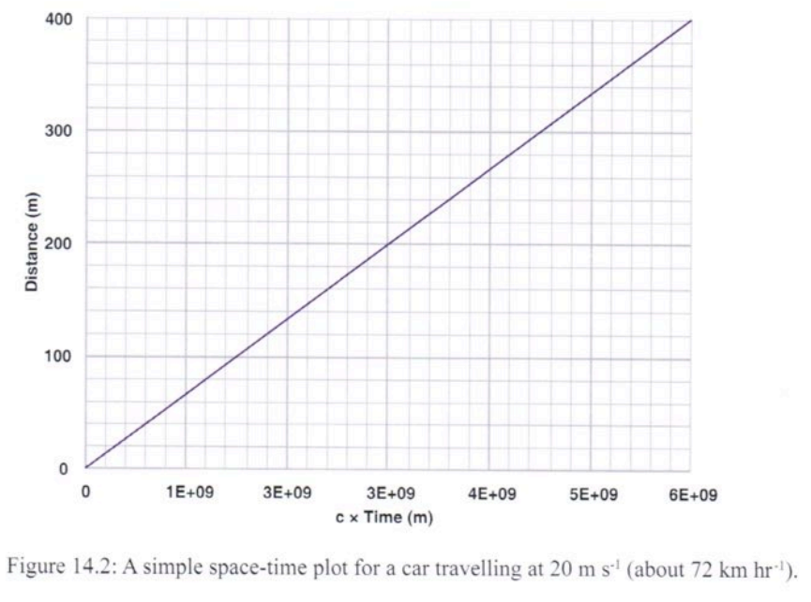
The space-time trajectories of 2 particles – one travelling at 0.95c and another at 0.99c (the solid line represents the speed of light:
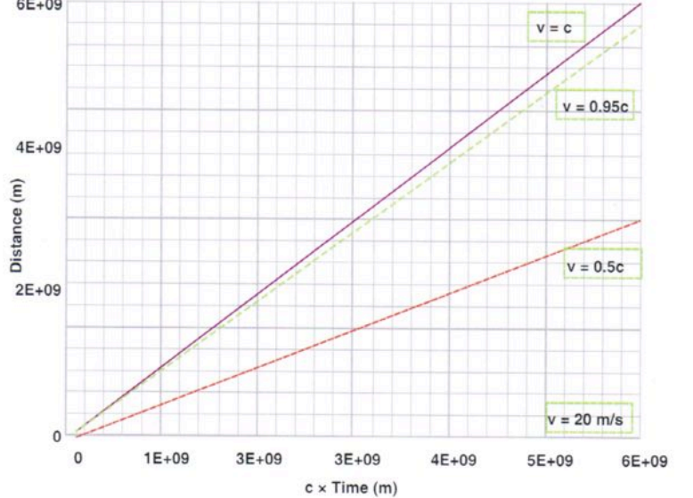
Consider a photon accelerated in a particle accelerator. The following occurs:
- Energy must be added to the system to increase its speed.
- More of the added energy goes towards increasing the particle’s resistance to acceleration (relativistic mass).
- Less of the added energy goes into increasing the particle’s speed.
- Eventually, the amount of added energy required to reach the speed of light would become infinite. The proton never reaches the speed of light no matter how much energy is added (universal speed limit).

Relativistic energy and momentum increase significantly at speeds approaching the speed of light.
At these speeds, enormous amounts of energy are required. Therefore, no massive particle can ever reach the speed of light.

Relativistic momentum:
p_{v} = $\frac{mv}{\sqrt{1-\frac{v^{2}}{c^{2}}}}$
This equation indicates that mass is a relative quantity. It increases with speed and becomes extremely large as it approaches the speed of light.

Relativistic mass:
m = $\frac{m_{0}}{\sqrt{1-\frac{v^{2}}{c^{2}}}}$ where m is relativistic mass and m₀ is rest mass.
When the velocity is much less than c, m=m₀.

Relativistic energy and mass energy equivalence:
E = $\frac{{mc}^{2}}{\sqrt{1-\frac{v^{2}}{c^{2}}}}$
If we apply this expression to a body at rest (v=0) the value of $\frac{v^{2}}{c^{2}}$ becomes zero.
E₀ = mc² where E₀ is rest energy associated with a mass m at rest.

A body’s total relativistic energy consists of its rest energy and any relativistic kinetic energy due to motion.
E = mc² + E_{k}
E_{k} = $\frac{{mc}^{2}}{\sqrt{1-\frac{v^{2}}{c^{2}}}}$ – mc²
$$E_{k}=\frac{{mc}^{2}}{\sqrt{1-\frac{v^{2}}{c^{2}}}}-mc^{2}=$$
$${mc}^{2}((1-\frac{v^{2}}{c^{2}})^{-\frac{1}{2}}-1)$$
$$Let E\left(v\right) be a function for relativistic kinetic energy$$
$$E'(v)=\frac{1}{2}{mc}^{2}(1-\frac{v^{2}}{c^{2}})^{-\frac{3}{2}}$$
$$E"(v)=\frac{3}{4}(1-\frac{v^{2}}{c^{2}})^{-\frac{5}{2}}$$
$$Let n represent the derivative number$$
$$E^{\left(n\right)}(v)=\frac{2n-1}{2^{n}}(1-\frac{v^{2}}{c^{2}})^{-\frac{2n+1}{2}}$$
$$E^{\left(n\right)}\left(0\right)=\frac{2n-1}{2^{n}}$$
$$E\left(v\right)=\sum_{n=1}^{∞}{\frac{E^{\left(n\right)}\left(0\right)}{n!}}=$$
$$\sum_{n=1}^{∞}{\frac{2n-1}{2^{n}n!}(\frac{v^{2}}{c^{2}})^{n}}$$
$$E_{k}=\frac{{mc}^{2}}{\sqrt{1-\frac{v^{2}}{c^{2}}}}-mc^{2}={mc}^{2}E\left(1\right)=$$
$${mc}^{2}\left(\frac{1}{2}\right)\left(\frac{v^{2}}{c^{2}}\right)=\frac{1}{2}mv^{2}$$
$$∴E_{k}=\frac{1}{2}{mv}^{2}$$
$$We can neglect the higher order terms if \frac{v^{2}}{c^{2}} is small$$

Photons:
- At the speed of light, the energy of the particle would become infinitely great. It would require an infinitely large amount of energy to accelerate the particle to the speed of light.
- Photons have zero rest mass meaning the energy of a photon is all kinetic energy.
- If a photon is forced to come to rest (absorption), it simply ceases to exist.

Simultaneity:
- Whether or not 2 events occur simultaneous depends on your frame of reference. The time order of events that are close together in time but distant in space can be different in different frames.

Imagine a train moving with uniform high velocity. A light source located in the centre of the train transmits a light pulse in all directions. A detector (or clock) at the front and rear of the train record he moment a pulse of light is detected. Marie, an observer on board the train, recognises that the pulse strike each detector simultaneously. At this moment, an observer named Albert on a “stationary” platform observes the train pass by as the light pulses are emitted.
As light travels out from the source, according to Albert, the stationary observer, it must be travelling at the speed of light in both directions. After the pulses are emitted, the rear of the train has moved closer to the source and therefore has less distance to travel. The forward going pulse has further to travel. Albert perceives that the light pulse has reached the rear detector first and he concludes that the 2 pulse direction events aren’t simultaneous.
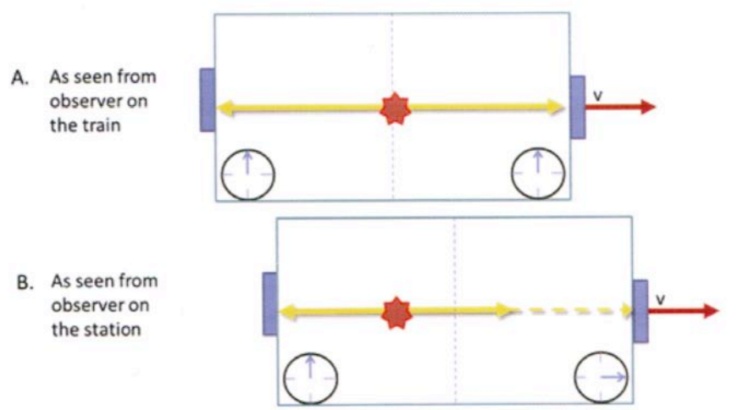
A light source located in the centre of the train transmits a light pulse in all directions. An observer on the train sees the pulses strike each detector simultaneously. A stationary observer sees the light pulse reach the rear detector first.

- 2 events that are simultaneous in one reference frame in general don’t appear to be simultaneous in a second frame moving relative to the first.
- Simultaneity isn’t an absolute concept but rather one that depends on the state of motion of the observer.
Imagine you’re looking at a row of trees in an orchard. Standing at a position at the end of the row, you can see the trees in a line in front of you and you could say that they all share the same y-coordinate. From another vantage point, say some distance perpendicular to the line, we can see the trees separated by 2m, but if you think of time as just another “direction”, you can believe that your time coordinate could’ve been one value in one reference frame and another value in a different frame.

Time dilation:
- The idea of a light clock is to use the distance travelled by a pulse of light and the known speed of light to mark out intervals of time.

Albert, inside a train carriage, sets up an experiment where he directs a pulse of light to a mirror on the roof of the train. The beam returns to its starting position and the time for the return trip is measured. This is shown in part A of the following diagram.
Part B is to imagine the train moving at high velocity through the station from left to right and consider how the light pulse would appear to marie who’s standing on the platform of a railway station. She’d observe he path of the light pulse as 2 diagonal paths as shown.
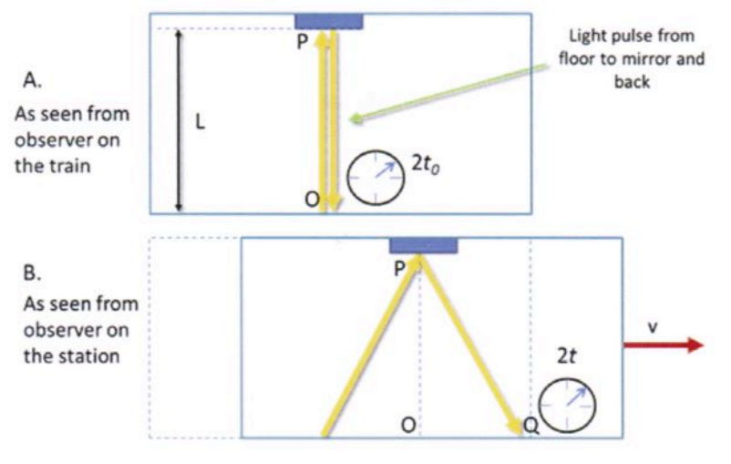
The length of of the light path PQ as viewed by Marie on the platform is longer than the path PO as observed by Albert in the train carriage. The speed of light “c” is the same for both observers so therefore time as measured by Albert, the moving observer, must be ticking “slower” than time as observed for Marie, the stationary observer.
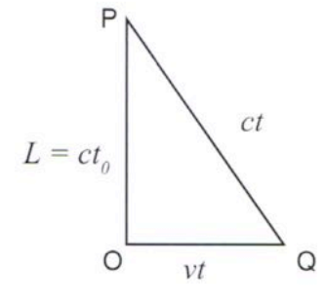
$$(ct)^{2}={(vt)}^{2}+(ct_{0})^{2}$$
$${(ct}_{0})^{2}={(ct)}^{2} – {(vt)}^{2}$$
$$t_{0}=t\sqrt{1–\frac{v^{2}}{c^{2}}}$$
$$γ=\frac{1}{\sqrt{1{–β}^{2}}} → t = γt_{0}$$
Where t₀ is the time as measured in the frame of the moving light-clock and t is the time as measured by the stationary observer. $γ$ is the Lorentz factor.

WACE Study Guide:
A racing driver has 2 mirrors set up on opposing sides of his speeding car so that the pulses of bright light can be reflected back and forth. He has a watch which is able to accurately measure the time taken for these pulses of light to travel from one mirror and back again.
A stationary observer watches the car speeding past and is also able to make accurate measurement of the time taken for the light pulses to travel form one mirror and back again. Each person will have a different view of the motion of the light beam.
From his frame of reference, the driver sees the light pulse move back and forth in the same line while the stationary observer sees the light move through a longer triangular pulse. Since the speed of light is constant for both viewers, the time measured by the stationary observer must be longer.
The time measured by the driver is referred to as “proper time” as it’s measured in the driven inertial reference frame. The stationary observer would measure a longer time for the same event. This time dilation is only observable when inertial reference frames are moving at near light speeds relative to each other.
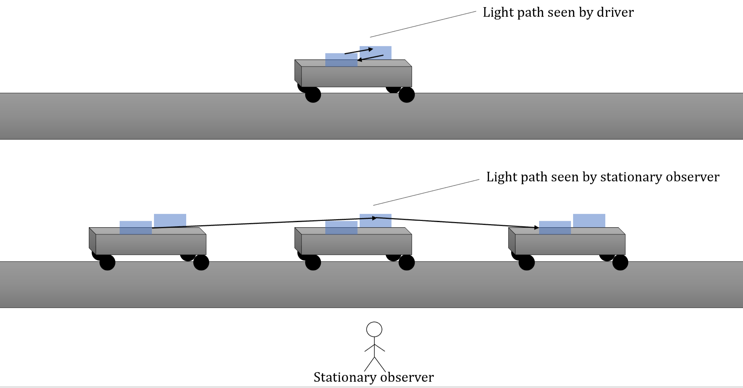
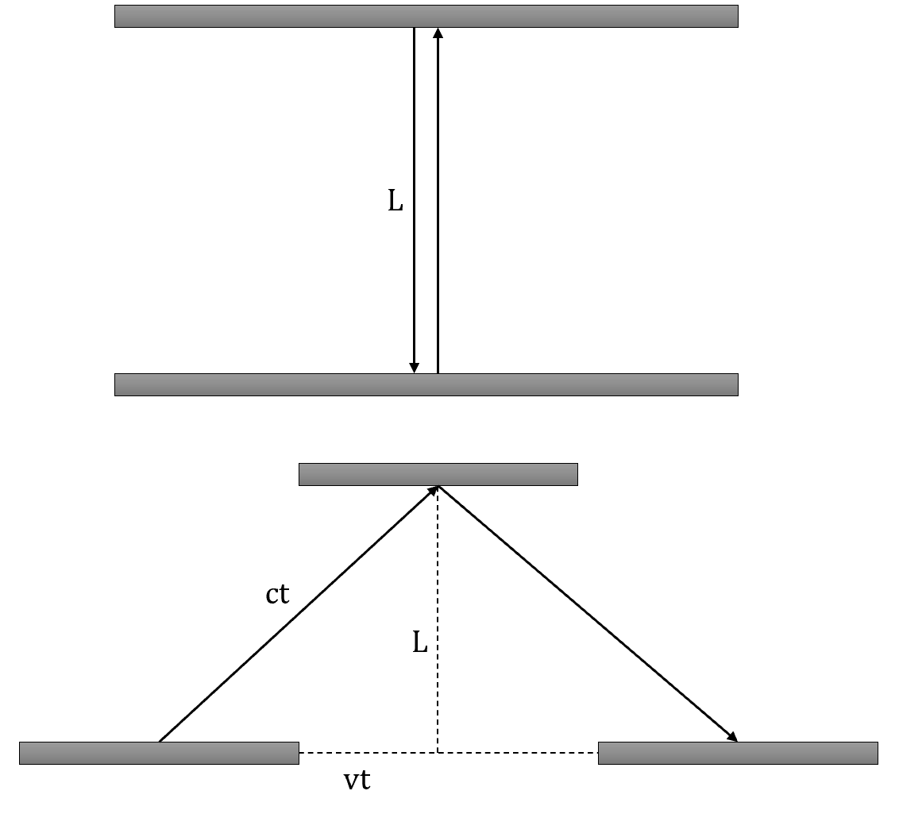
$$(ct)^{2}=L^{2}+({vt)}^{2}$$
$$c^{2}t^{2}=c^{2}{t_{0}}^{2}+v^{2}t^{2}$$
$$t^{2}={t_{0}}^{2}+\frac{v^{2}}{c^{2}}t^{2}$$
$$t^{2}\left(1-\frac{v^{2}}{c^{2}}\right)={t_{0}}^{2}$$
$$t=\sqrt{\frac{{t_{0}}^{2}}{1-\frac{v^{2}}{c^{2}}}}=\frac{t_{0}}{\sqrt{1-\frac{v^{2}}{c^{2}}}}$$
Where:
- t₀ is time measured in the moving frame of reference (proper time).
- t is time measured by a stationary observer.
- v is velocity of moving frame of reference.
- c is velocity of light.

The Lorentz transform:
It’s a way to bring observers of different velocities at different places together so they can “compare notes”. It takes into account the fact that the speed of light is constant and finite, but distance and time aren’t constant.
If you’re observing a building from the front entrance and a friend 2 streets away observes the same building, how’d you compare your observations about the size and shape of the building?
In the Lorentz transform, measurements in the direction of motion are adjusted by a factor γ.
γ = $\sqrt{1–\frac{v^{2}}{c^{2}}}$ = $\frac{1}{\sqrt{1{–β}^{2}}}$
Where v is the relative velocity of the 2 reference frames and c is the speed of light. γ is always greater than one because v is always less than c.

A plot of γ and $\frac{1}{γ}$ for speeds up to the speed of light:
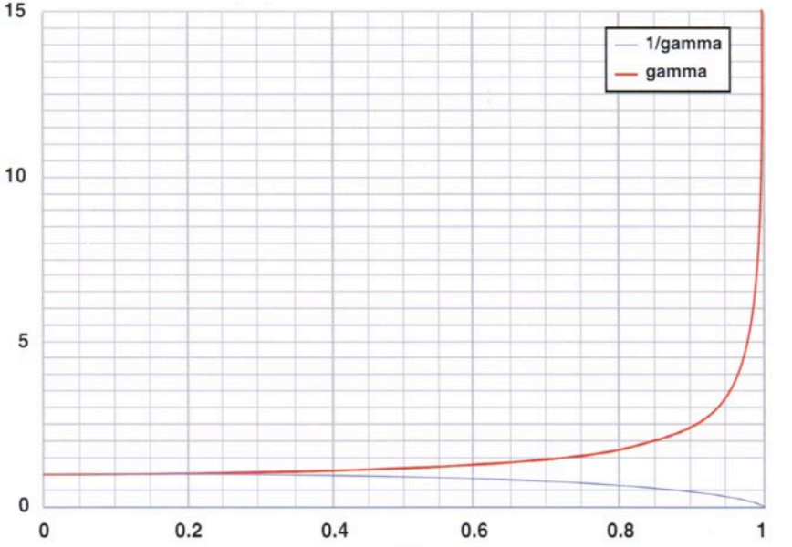
Relativity of length:
- As objects move through space-time, space and time change.
- As an object travels at relativistic speeds, it contracts or gets shorter.
- Because simultaneity is relative and it enters into length measurements, length is also a relative quantity.
Measuring the length of a moving train by locating its front and back at the same time:
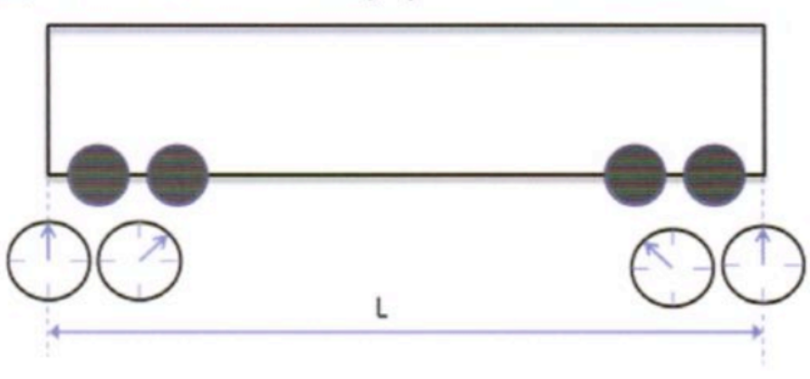
Marie is on the train with synchronised clocks placed at each end. Albert is on the station. By carefully setting up the clocks, Marie sees the front clock strike noon as the train exits the tunnel and the back clock trike noon as the train enters the tunnel. To Marie, the clocks strike noon simultaneously and she concludes that the train fits exactly in the tunnel. For Albert, the back clock strikes noon first and the front clock a little later, so he concludes that the train is shorter than the tunnel.
The key to understanding this is to ask how one might measure the length of a moving object.
To measure the speed of a very fast train, we need a set of stationary clocks spread out at known positions. The measurement of length consists of recording the simultaneous positions of the 2 ends of the train – we might need multiple observers to do this. The instructions might be to report in if you see either end of the train at your location at precisely noon. We can work out, by knowing who reported in, where the ends of the train were at the chosen time.

- Moving objects are length-contracted – they appear shorter to an observer in a stationary frame of reference.
- Length contraction occurs only along the direction of relative motion.
$\frac{L}{L_{0}}$ = $\sqrt{1–β^{2}}$
L = $\frac{L_{0}}{γ}$
Where L₀ is the length of train measured by an observer in the train and L is the length as measured by the observer in a stationary reference frame.

WACE Study Guide:
- Like time, length measurements are different for inertial reference frames with relative motion between them.
- Proper length: Length measured in the observer’s frame of reference.
- The length of a moving object will always appear shorter in he direction of the motion when measured by a stationary observer.
- Consider the racing driver example, but in this case the mirrors are set up in the line of motion of the car.
This time, we’re interested to see if the measured length L between the mirrors is the same for the driver as it is for the stationary observer. The measurement is made indirectly by noting the time taken for each light pulse journey as it’s impossible to measure the position of the 2 end points simultaneously and allows for the fact that the mirror positions change during measurements.
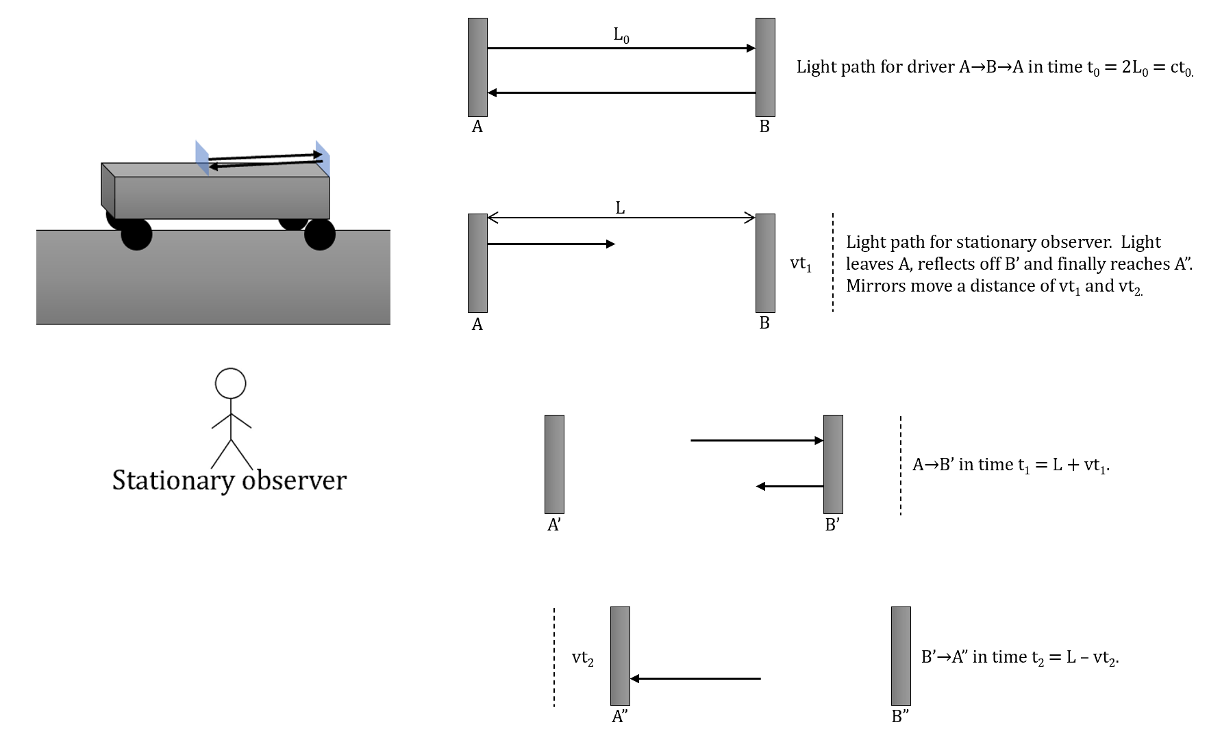
For the driver, the light travels a distance 2L₀ in a time of t₀ hence the length is given by ct₀. This is the proper length. Similarly, for the stationary observer, the light travels a length of ct₁ + ct₂ in total time t.

Total distance that light travelled for the driver:
In time t₀:
$$A→B→A={2L}_{0}={ct}_{0}$$

Total distance that light travelled for the stationary observer:
In time t₁:
$$A→B'={ct}_{1}+{vt}_{1}$$
In time t₂:
$$B'→A"={ct}_{2}-{vt}_{2}$$
Where v₁t and v₂t are the distances that the mirrors moved.

Total time:
$$t=t_{1}+t_{2}$$
$${L=ct}_{1}-{vt}_{1}=t_{1}\left(c-v\right)→t_{1}=\frac{L}{c-v}$$
$$L={ct}_{2}+{vt}_{2}=t_{2}\left(c+v\right)→t_{2}=\frac{L}{c+v}$$
$$t=t_{1}+t_{2}=\frac{L}{c-v}+\frac{L}{c+v}=$$
$$\frac{L\left(c+v\right)+L\left(c-v\right)}{\left(c-v\right)\left(c+v\right)}=$$
$$\frac{Lc+Lv+Lc-Lv}{c^{2}-v^{2}}=$$
$$\frac{2Lc}{c^{2}-v^{2}}=$$
$$\frac{2L}{c-\frac{v^{2}}{c}}=$$
$$\frac{2L}{c(1-\frac{v^{2}}{c^{2}})}=$$
$$∴t=\frac{2L}{c(1-\frac{v^{2}}{c^{2}})}$$

$$t=\frac{t_{0}}{\sqrt{1-\frac{v^{2}}{c^{2}}}}=\frac{2L}{c(1-\frac{v^{2}}{c^{2}})}$$
$$t_{0}=\frac{2L_{0}}{c}→\frac{\frac{2L_{0}}{c}}{\sqrt{1-\frac{v^{2}}{c^{2}}}}=\frac{2L}{c\left(1-\frac{v^{2}}{c^{2}}\right)}$$
$$\frac{\frac{2L_{0}}{c}c\left(1-\frac{v^{2}}{c^{2}}\right)}{\sqrt{1-\frac{v^{2}}{c^{2}}}}=\frac{2L_{0}\left(1-\frac{v^{2}}{c^{2}}\right)}{\sqrt{1-\frac{v^{2}}{c^{2}}}}=2L$$
$$L=\frac{L_{0}\left(1-\frac{v^{2}}{c^{2}}\right)}{\sqrt{1-\frac{v^{2}}{c^{2}}}}=L_{0}\sqrt{1-\frac{v^{2}}{c^{2}}}$$
$$∴L=L_{0}\sqrt{1-\frac{v^{2}}{c^{2}}}$$
Velocity transformation:
When we have relative motion between 2 reference frames, say S and S’:
$$u^{'}=\frac{u–v}{1–\frac{uv}{c^{2}}}$$
$$u=\frac{{v+u}^{'}}{1–\frac{{vu}^{'}}{c^{2}}}$$
Where:
- u’ is velocity of an object moving in frame S’.
- u is velocity of that same object as viewed from frame S.
- v is relative velocity between reference frame S and S’.
- c is velocity of light.
At velocities much smaller than the speed of light, $\frac{uv}{c^{2}}$ essentially becomes zero.

Galilean transformations give accurate results at low speeds and are hence most commonly used for classical physics problems. At high velocities the results become inaccurate.
The relativistic equations apply and are true at all velocities.

Relativity of velocities:
A spacecraft travelling at 0.9c fires a missile which it observes to be moving at 0.8c with respect to it. Velocities must transform according to the Lorentz transformation and that leads to Einstein velocity addition.
To analyse the situation, we can consider 2 observers in relative motion with respect to each other who are both observing the motion of the missile. How do they measure the velocity of the object relative to each other if the speed of the object is close to that of light? We can consider a reference frame S’ moving at a speed v relative to S. The missile has a velocity u’ measured in the S’ frame. The velocity u is the speed of the missile relative to frame S.
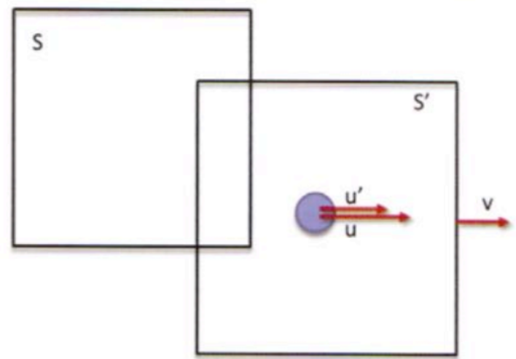
u’ = $\frac{u–v}{1–\frac{uv}{c^{2}}}$ , u = $\frac{u^{'}+v}{1–\frac{u^{'}v}{c^{2}}}$ when v is much less than the speed of light c, the denominator of the equation for u’ approaches unity and so u’ = u–v which is the Galilean velocity transformation equation. It’s what we’d expect in the non-relativistic case.
When u approaches the speed of light:
$$u'=\frac{c–v}{1–\frac{cv}{c^{2}}}$$
$$=\frac{c–v}{1–\frac{v}{c}}$$
$$\frac{c(1–\frac{v}{c})}{1–\frac{v}{c}}$$
$$=c$$
Conclusion: The speed of a particle travelling close to the speed of light measured by an observer in frame S is also measured as c by an observer in S’ independent of the relative motion of S and S’.

2 observers agree on:
- Their relative speed of motion with respect to each other.
- The speed of any ray of light.
- The simultaneity of 2 events which take place at the same position and time in some frame.
2 observers don’t agree on:
- The time interval between events that take place in one of the frames.
- The distance between 2 fixed points in one of the frames.
- The velocity of a moving particle.
- Whether 2 events are simultaneous or not.

Relative velocities:
Reference frames (coordinate systems) are a useful concept in comparing measurements made by 2 observers moving relative to each other.
If we consider 2 reference frames S and S’, each point in S (x, y, z) has a corresponding point in S’ (z’, y’, z’). Consider an event occurring in frame S’ as viewed by an observer in frame S. If frame S’ is moving away from frame S with a velocity v:
$$x=x^{'}+vt'$$
$$y=y^{'}$$
$$z=z^{'}$$
$$t=t^{'}$$
This is known as the Galilean transformation and only holds for velocities much less than the speed of light. Point x’ has moved away from x in the x direction by an amount vt. It’s assumed that the reference frames were both at the origin at t=0, the clocks are synchronised and they’re running at the same rate.

u = v + u’ where:
- u’ is velocity of an object moving in frame S’.
- u is velocity of that same object as viewed from frame S.
- v is relative velocity between frames S and S’.
u’ = u – v applies for an object moving in frame S as seen from frame S’. These equations show that we can simply add the velocities as vectors.
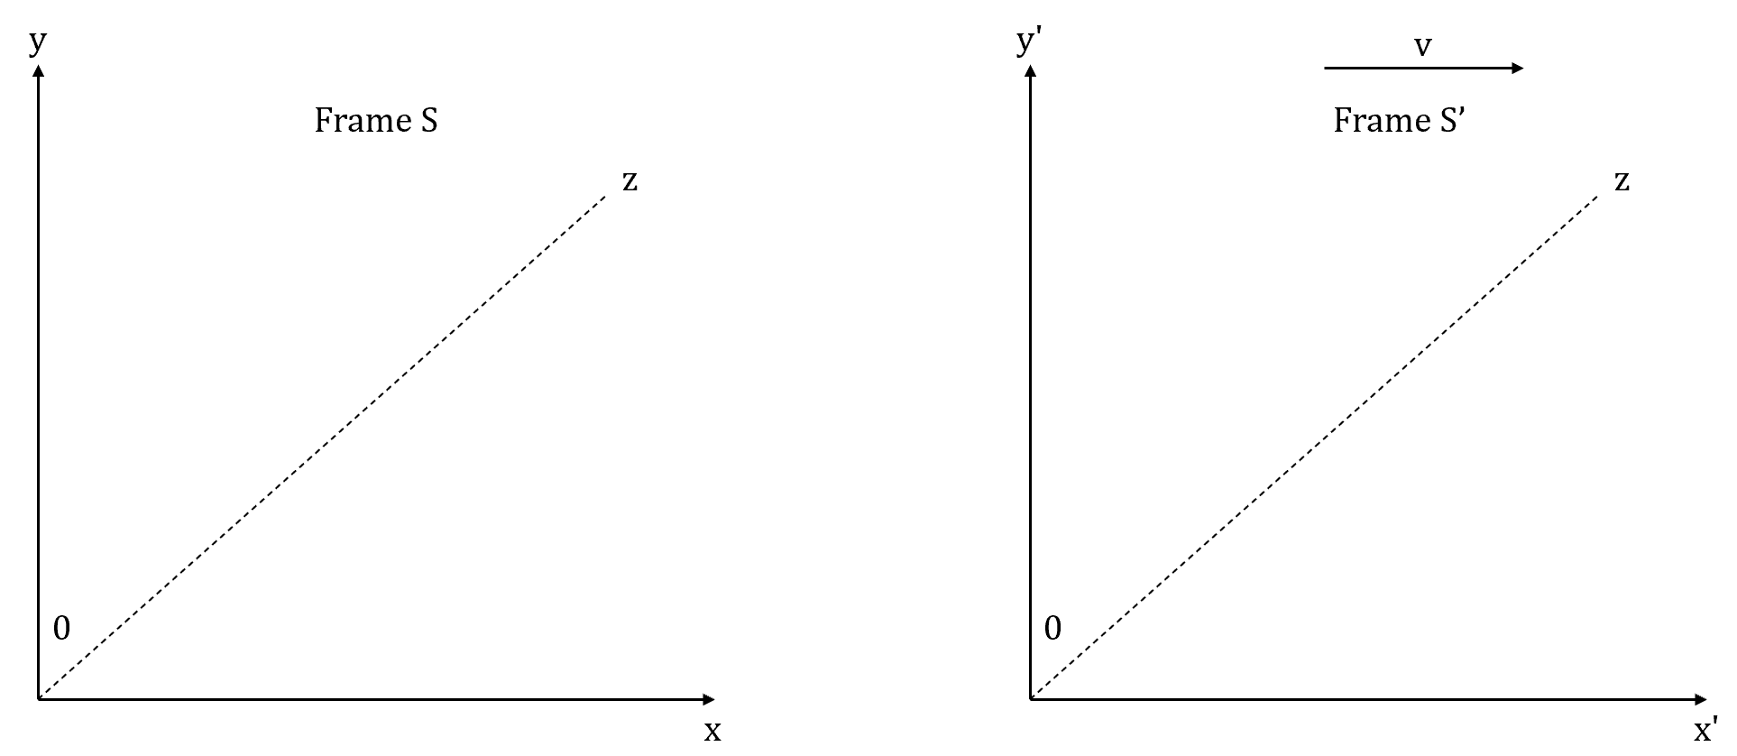

Set 14.1
Q: Are 2 vehicles moving at different but constant velocities in the same inertial reference frame?
Not necessarily. They’re both inertial frames but not the same frame. Measurements in one inertial frame can be converted in another by a simple transformation.

Q: What does the term “proper time” mean in special relativity?
The time between 2 simultaneous events as seen and measured by an observer who’s stationary relative to the object on which measurements are being made.

Q: 2 trains are moving at different but constant velocities. Ar there any conditions under which they’re in the same inertial reference frame? Do 2 non-inertial reference frames imply that one frame is accelerating?
Having different velocities means they must be in different frames of reference. This includes having the same speed but moving in different directions or having different speeds in the same direction. In both of these cases, there’ll be an acceleration because a change in velocity exists. If a frame isn’t non-inertial, it must be undergoing an acceleration and therefore not have a constant velocity. 2 non-inertial frames will also be accelerating with respect to each other unless they’re accelerating in exactly the same way and in the same direction.

Q: 2 spaceships are launched from the same place at the same time in opposite directions, both eventually reaching a velocity of 0.7c in their respective directions. The technicians at the launch site see both of these spaceships as travelling away from them at 0.7c. When the second spaceship is viewed from the first and vice versa, what would the velocity of the other ship be? Numerically, it would appear that the speed of either ship is moving away from the other is 1.40c. Discuss the validity of this supposition.
Velocities don’t add up like they do in Newtonian mechanics. The relativity of space and time extends to velocity. The 2 quantities can be added together and the relative velocity for this data will be $\frac{(0.7+0.7)c}{1+0.7x0.7}$ = $\frac{1.4c}{1.49}$ = 0.94c.

Q: Given a jet fighter can fly at supersonic speed, does design allowance need to be incorporated to accommodate any shrinkage in length? Would this be necessary in spacecraft design if the spacecraft could travel at near light speed? Explain.
The Lorentz contraction isn’t significant for an aircraft flying at a speed well below the velocity of light so there are no design issues to consider. It isn’t necessary to worry about Lorentz contraction in any ship design regardless of speed because such contraction is relative and measured form a frame external to that of the ship. In the ship’s own frame it has its proper length.

Q: Is the density of the material from which a relative spaceship is constructed itself relative?
Density is mass per unit volume. Relativistic speed will result in a relativistic mass increase and a relativistic length decrease, hence a relativistic increase in density.

Q: Alpha Centauri is a star 4.367 light years from Earth. A time traveller taking this journey at near light speed in a starship was confused by the fact that he made the journey in less than 4 years based on his clock. How would you explain this situation to the traveller? How would this dilemma be viewed by an observer on Earth?
When viewed in the reference frame of the starship, the distance between the Earth and Alpha Centauri is seen as being length contracted and the clock is running normally. To the Earth-based observer, the spaceship clock is seen as being time dilated by the same factor but the distance is unchanged. Observers in both locations agree the journey time is the same relative to their own frames of reference but their reasons are quite different – one being due to time dilation and the second to length contraction.

Q: Explain if or how the density of a material is affected when it’s travelling at relativistic velocities.
The relativistic mass of an object clearly increases as velocity increases. The length also decreases at relativistic speeds. If length contracts then volume must decrease and as density = $\frac{mass}{volume}$ an increase in mass and decrease in volume must result in an increase in density.

Q: A diagram of a beam of light bouncing off mirrors shows that time in a moving spacecraft must run slow as seen by a stationary observer.
[a] Explain why there must be length contraction.
Length contraction and time dilation make the speed of light constant.
[b] Is this contraction real or an optical illusion?
An observer outside would see that the spaceship would’ve changed its shape, being shorter in the direction of travel. However, in the spaceship’s frame everything has its proper length.

Q: When an object travels at near light speed we talk about the effects of time dilating relative to an observer in a different reference frame and length contracting to approach zero as its velocity reaches light speed. Why is it that light itself isn’t subject to these 2 effects?
To a photon of light, distance and time don’t exist, so light is in effect subject to the effects mentioned.

Q: Special relativity considers the speed of light as being constant in all reference frames. How does this explain refraction of a beam of light by a glass prism when tis is said to occur because the velocity of the light has decreased?
Light within a prism appears to travel slower. This is due to the interaction of the electromagnetic wave with electric and magnetic fields within the material.

Q: You’re in a spaceship with no window, radios or other means to check outside. How would you determine if the spaceship is at rest or moving at constant velocity?
In your perspective, your clock runs exactly the same as it did when you were at rest on Earth. All objects in your ship appear the same to you as they did before and the speed of light is still c. There’s nothing you can o to find out if you’re actually moving.

Q: It’s said that Einstein, in his teenage years, asked the question “what would I see in a mirror if I carried it in my hands and ran with the speed of light?” How would you answer this question?
The speed of light is the same in all reference frames independent of the speed of the source or the observer. Therefore, the light still travels at the speed c and what you see in the mirror will be exactly the same as what you’d see if you were at rest.

Q: You’re riding in a spaceship travelling at 0.6c when you shine your headlights into the distance. Another spaceship is travelling forwards, you and a scientist on board measures the speed of the light beam coming from your spaceship. What will he observe?
The scientist will observe the light beam reaching him at speed c. Because of the principle of the constancy of the velocity of light, each observer will measure the light beam from the headlight as travelling at the same speed.

